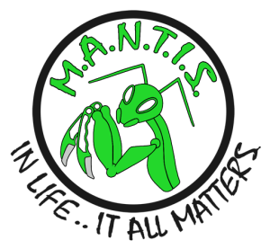

M.A.N.T.I.S. LLC • 111 N. Iron St. • Deming, New Mexico 88030 • 832-262-0262

**2018 SEMINAR REGISTRATION FORM**

I, Undersigned, understand that I am enrolling in the MANTIS, LLC Seminar as checked below.

I, Undersigned, acknowledge that I am remitting a non-refundable $20.00 fee per seminar as selected below.

With my signature below, I, Undersigned, acknowledge and agree that I have read this instrument and understand its terms and that I am executing this instrument voluntarily.

UNDERSIGNED

NAME: __________________________________________ DATE: _______________

ADDRESS: ________________________________________________________________

PHONE #: ________________________________________________________________

SIGNATURE: ________________________________________________________________

Check the date(s) you wish to attend

|  |  |  |  |  |  |  |  |
| --- | --- | --- | --- | --- | --- | --- | --- |
| **Anti-Kidnapping** | |  | **Tactical Training** | |  | **Women’s Self-Defense** | |
|  | Aug, 18th *(Saturday)* |  |  | June, 23rd *(Saturday)* |  |  | July, 21st (Saturday) |
|  | Nov, 3rd *(Saturday)* |  |  | Sep, 22nd *(Saturday)* |  |  | Oct, 20th (Saturday) |
|  |  |  |  | Dec,15th *(Saturday)* |  |  |  |

(Make check payable to: William Reynolds - Mail to 111 N. Iron St., Deming, NM 88030)

**FOR STAFF USE ONLY!**

|  |  |  |  |  |  |  |  |
| --- | --- | --- | --- | --- | --- | --- | --- |
| **FOLLOW-UP** | |  | **FOLLOW-UP** | |  | **FOLLOW-UP** | |
|  | Contacted |  |  | Contacted |  |  | Contacted |
|  | Left Message |  |  | Left Message |  |  | Left Message |
|  | No Contact |  |  | No Contact |  |  | No Contact |

Comments: _______________________________________________________________

________________________________________________________________________

________________________________________________________________________